**UNITED STATES AIR FORCE ACADEMY DEPARTMENT OF ELECTRICAL AND COMPUTER ENGINEERING**

**ECE 332 Laboratory Exercise 7d**

**RLC Circuit Design**

**C3C’s Mark Demore and Luke McFadden**

**1. Objective**

The objective of this lab was to introduce the engineering design process as applied to circuit design. Secondary objectives for the lab include: designing an RLC circuit to meet step-response specifications, test, and build the aforementioned circuit.

**2. Specifications and Limitations**

The RLC circuit designed in the lab was required to meet specifications given in the table below, dependent upon our social security number. The circuit was also to be built with standard component values, and more specifically, only those available in the lab. Given our social security numbers, ending in 48 and 62, we opted to selected the values featured in Table 1 corresponding to the final digits of 48 for our specifications.

**Table 1. Assigned Design Specifications**

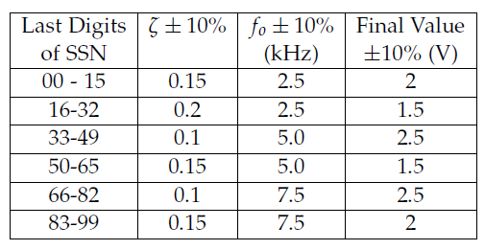

**3. General Approach**

The approach to go from specification to circuit was simple. First, we developed the equations relating ζ and f0 to R, L and C. From there, we went through a series of iterations of substitution using available inductor values to determine appropriate available resistor and capacitor values. These RLC values were substituted in and altered, in regards to the restraints, until our results were within the given tolerance laid out in Table 1.

**4. Design**

1. **Mathematical Equation**

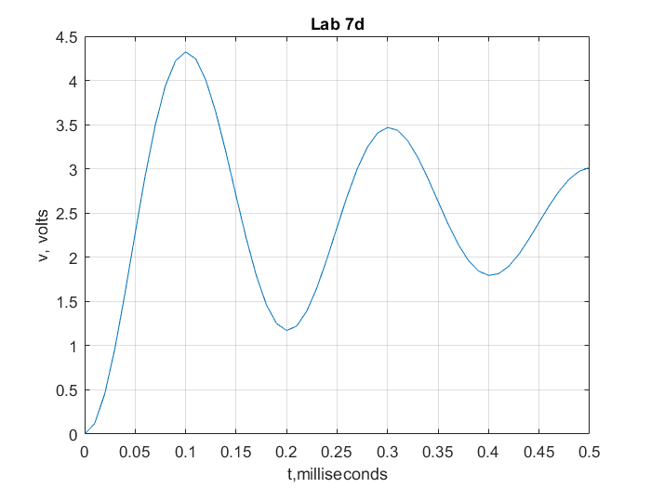The governing differential equation for a series RLC circuit is $s^{2}+\frac{R}{L}s+\frac{1}{LC}=0$. From this governing ODE, the resultant equations for ζ and f0 are: and $f_{0}=\frac{1}{2π\sqrt{LC}}$. From these equations, we can determine that a greater R would lead to greater damping, and conversely, a smaller R would lead to less damping. This relationship is very useful when determining values for a specific ζ, the damping term. The given specifications were used to substitute back into the governing ODE in order to generate the waveform depicted below in Figure 1, using MatLab.

**Figure 1. Theoretical Waveform**

**b. Circuit Simulation**

As mentioned previously in Mathematical Equation and General Approach, the necessary equations to determine the RLC values to meet the given specifications were: $ζ=\frac{R}{2}\sqrt{\frac{C}{L}}$ and $f_{0}=\frac{1}{2π\sqrt{LC}}$. Given that the equation for f0 only has two variables, it was used to solve for a capacitor value based on a guess inductor value. The capacitor value was then approximated to a standard value, and those values were substituted into the ζ equation to solve for a resistor value. The resistor was approximated to a standard value and then ζ and f0 were calculated with those values to ensure that they were within the given tolerance. Once the conditions were met, the circuit schematic was created in Multisim and a waveform was generated. The simulated waveform is depicted below in Figure 2.

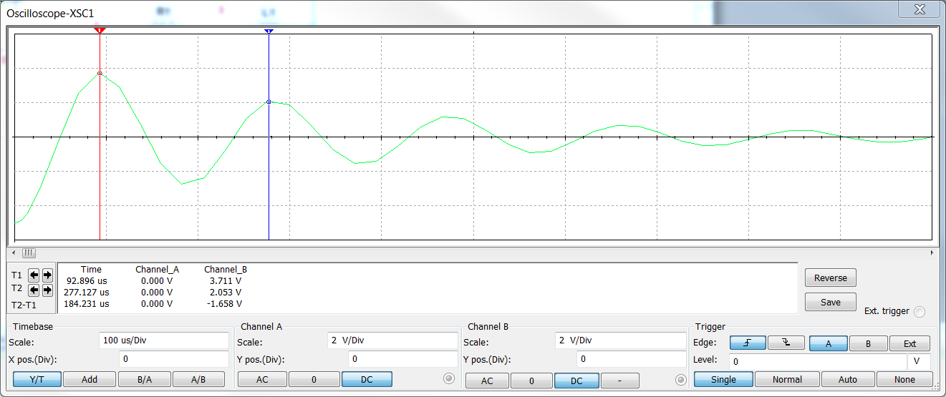

**Figure 2. Multisim Waveform**

1. **Realistic Values**

All calculations were done with realistic values in mind. Considering this, the simulation wave form is representative of the realistic wave form. The table below shows the disparity of f0 and ζ values, using standard components.

**Table 2. Percent Error Using Realistic Values.**

|  |  |  |  |
| --- | --- | --- | --- |
| Parameter | Ideal Value | Realistic Value | Percent Error |
| ζ | 0.1 | 0.1007 | 6.1% |
| f0 | 5kHz | 5.5579kHz | 10.03% |
| v(∞) | 2.5V | 2.5V | 0% |

**5. Implementation**

The first step in building the circuit was picking out the components in the lab. Given the need to consider parasitic resistance of the inductor, that was selected first and the resistance was measured. The resistance of the inductor was then subtracted from the total resistance of the circuit, along with the resistance of the function generator, a very small value for the myDAQ, to determine the required resistor value. The R, L and C values of each respective component were measured to ensure they came from the correct bin in the lab and to account for any potential error. The schematic for the ideal circuit, using standard values, is pictured below.

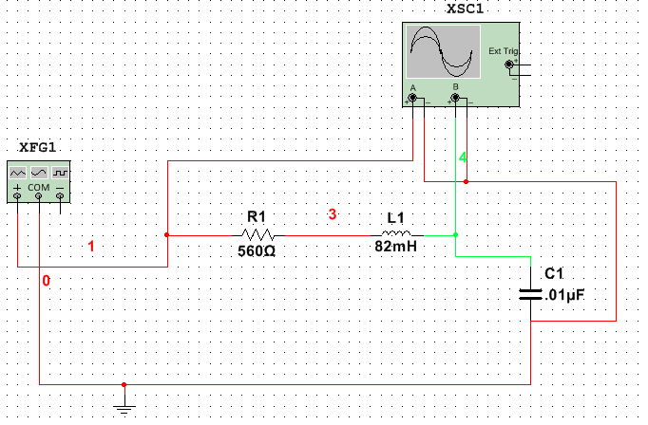**Figure 3. Schematic**

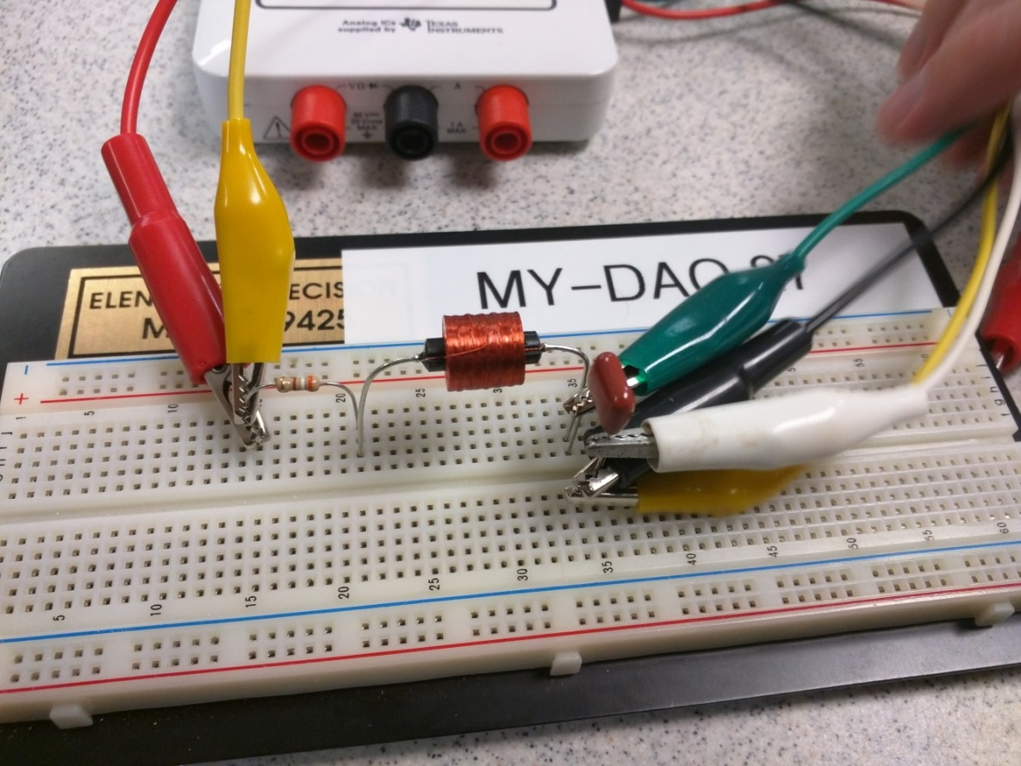Once the values were confirmed and the components were tested and verified, we began wiring up the RLC circuit. The completed implementation of our design is below, featuring a resistor value of 390Ω, actually 383.5Ω, a capacitor value of 0.01μF, actually 0.010194μF, and an inductor value of 82mH, actually 84.59mH with a parasitic resistance of 187.01Ω, and a resistance from the function generator of 1Ω. The completed circuit is pictured below in Figure 4.

**Figure 4. myDAQ Circuit**

**6. Analysis and Testing**

The circuit was tested using the virtual instruments featured in the myDAQ National Instruments software, specifically the function generator and the oscilloscope. The oscilloscope output is featured below in Figure 5.

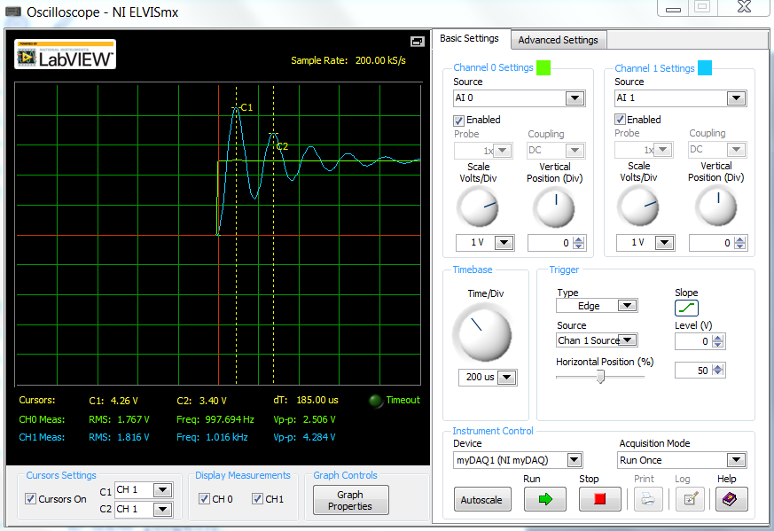

**Figure 5. Built Circuit Response**

From Figure 5, the logarithmic decrement was calculated using the cursors and peak values over the first two oscillations in order to calculate ζ. Also, the time between the two peaks was used to calculate f0, and the cursor was moved to a time were the underdamped system attained its final value to calculate the final specification.

**Table 2. Percent Error of Realized Circuit**

|  |  |  |  |  |  |
| --- | --- | --- | --- | --- | --- |
| **Parameter** | **Ideal**  **Value** | **Designed-to**  **Value** | **Built Value** | **Percent Error**  **Built Values** | **Percent Error**  **Designed Values** |
| ζ | 0.1 | 0.1007 | 0.1061 | 5.75% | 0.70% |
| fo | 5kHz | 5.5579kHz | 5.4054kHz | 7.49% | 10.03% |
| v(∞) | 2.5V | 2.5V | 2.5V | 0% | 0% |

Some potential sources of error that may have occurred throughout the lab include, the fact that the calculations were always done with standard part values in mind, skewing and approximating values throughout. Another possible source of error is the discrepancy between part values and their actual values, as shown in Table 3.

**Table 3. Actual Component Values**

|  |  |  |  |
| --- | --- | --- | --- |
| **Device** | **Component Value** | **Measured Value** | **% Difference** |
| Inductor | 82 mH | 84.59 mH | 3.15% |
| Capacitor | 0.01μF | 0.010194 μF | 1.94% |
| Resistor | 390 Ω | 383.5 Ω | 1.92% |
| Resistor Parasitic | N/A | 187.01 Ω | N/A |

**7. Conclusions**

The design performed within the given tolerance, and resulted in acceptable values very close to those given in the specifications. Lessons learned include the usefulness of: knowing what parts you have on hand before entering the design stage, not rounding the numbers in our calculations until the very end, and how frustrating algebra can be when your equation is slightly wrong (attention to detail.)

**Appendices**

**Plotting Code:**

clear all

zeta = .1

f = 5e3

A = 2.5

alpha = zeta*2*pi*f

beta = 2*pi*f*sqrt(1 - zeta^2)

t = 0:10e-6:500e-6;

v = A - A*exp(-alpha*t).* (cos(beta*t) + alpha/beta*sin(beta*t));

plot(1000*t,v)

xlabel('t,milliseconds')

ylabel('v, volts')

title('Lab 7d')

grid on

**Calculation Code:**

% Damping Function

clear all

close all

clc

R_sig = 1;

R_L = 186;

R_chosen = 390;

x1 = 1.76;

x2 = .9;

log_dec = log(x1/x2);

delta = log_dec^2;

%Rt = R_chosen + R_par + R_L;

Rt=560;

C = 0.01*(10^(-6));

L = 82*(10^(-3));

dampFact = (Rt/2)*(sqrt(C/L))

zeta = 1/((sqrt(1+(4*(pi^2))/(delta))))

f_0 = 1/(sqrt(L*C)*2*pi)